**UNIVERSITY OF DAR ES SALAAM**



**COLLEGE OF INFORMATION AND COMMUNICATION TECHNOLOGIES**

**DEPARTMENT OF ELECTRONICS AND TELECOMMUNICATION**

**ENGINEERING**

**PRACTICAL TRAINING REPORT**

**REPORT TITLE: ELECTRONIC QUEUEING SYSTEM**

**NAME: GAMBISHI, WINOCK ERICK**

**REG NO: 2021-04-01961**

**PROGRAM: BSC. ELECTRONICS ENGINEERING**

**PRACTICAL TRAINING YEAR: PT 3**

**COMPANY/ORGANIZATION NAME: ETE DEPARTMENT (CoICT)**

**TRAINIG OFFICER’S NAME: MR. JAMES MICHAEL**

**ACADEMIC SUPERVISOR’S NAME: DR. ULEDI HASHIMU**

# **ABSTRACT**

This report is submitted as an essential requirement of the completion of the Practical Training 3 course by University of Dar es Salaam in college of information and communication technologies. The practical training commenced on the 22th July 2024 to the 13th September 2024 at ETE DEPERTMENT(CoICT).

This report consists of the main task conducted during practical training which is the design and development of an electronic queuing system that will have user-friendly experience and increase efficiency in service centers

This project was handed over for the aim of creating a technological solution that will replace old ways of queuing processes by implementing a streamlined, automated system, potentially reducing discomforts that come with manual operations and long waiting times.

i

# **ACKNOWLEDGEMENT**

The first and foremost thing is to thank the Almighty God for the gift of life that is granted to us each day, Since the commencing of this Practical Training Program to the final end of the Main Project, the Almighty God has been of very great favor to me and all other team members as well as all staffs as a sum.

My deepest gratitude to the ETE Department for providing me with this opportunity to grow, elevate and nurture under their stewardship, supervision not only as a professional but also as a good human, that did allow me to unleash my skills in solving very critical societal challenges that affect our localities and the whole world at large by following the right steps and protocols. From my time at ETE Department did gain new skills that I now cherish and appreciate and also use in my personal growth and also in terms of improving my overall enthusiasm on my ICT field and in the Engineering journey.

I appreciate the faith shown by the head of department ETE, Prof. Baraka Maiseli for proving me and other students in the PT training all the required resources to complete given tasks, his softspoken nature and readiness to assist students reach their goals gave me confidence and morale in doing and completing tasks effectively.

My sincere thanks to the ETE department practical training officer, Mr. James Michael for the firm support during the whole period, supervision and openness for consultation played a part in the completion of various tasks and the project as a whole, and also equipping me with individual addition skills that are essential in engineering field.

I lastly extend my deepest appreciations to the team-mates who we together worked together each one with their tasks, for the support, their readiness and open mindedness during the whole period, to all mentioned and other more, thank you!

ii

**Table of Contents**

ABSTRACT i

ACKNOWLEDGEMENT ii

LIST OF FIGURES iv

LIST OF ABBREVIATIONS v

INTRODUCTION 1

PROBLEM STATEMENT 2

Proposed solution 2

OBJECTIVES 2

Main Objective: 2

Specific Objectives: 2

METHODOLOGY 3

BLOCK DIAGRAM OF THE SYSTEM 4

IMPLEMENTATION OF THE SYSTEM 5

Developing a token printing machine 5

Development and implementing counter for calling tokens 8

Establishing a centralized database to enable synchronization of token information across counters 11

To implement a display and a voice for token call up for better user experience 13

To integrate token printing into the rest of the electronic queuing system 16

ANALYSIS AND IMPORTANCE OF THE SYSTEM 18

CONCLUSION 20

RECOMMENDATION 20

References 21

iii

# **LIST OF FIGURES**

Figure 1: The block diagram of the system receiver and transmitter side……………….4

Figure 2: the Arda fruit printer….……………………………………………….………6

Figure 3: board mounted with components……………………………………………...6

Figure 4 The token printer cased………………………………………………………...7

Figure 5: Sample of a token……………………………………………………………...7

Figure 6: 4x4 Keypad……………………………………………………………………9

Figure 7: ESP 32………………………………………………………………………...9

Figure 8: ESP32 connected to keypad……………………………………………...…...9

Figure 9: The counters programmed……………………………………………………10

Figure 10: The customer visual interactive display…………………………………….16

iv

# **LIST OF ABBREVIATIONS**

**ICT**: Information Communication Technology

**CoICT**: College of Information Communication Technologies

**ETE**: Electronics and Telecommunication Engineering

**AI**: Artificial Intelligence

**RFID**: Radio frequency identifier

**SDGS**: **Sustainable Development Goals**

**Wi-fi**: Wireless fidelity

**GUI**: Graphical user interface

**LED**: Light emitting diode

**RBAC**: Role-Based access control

**GDPR**:

**API**: Application programing interface

**DBMS**: Database management systems

**PCB**: Printed circuit board

**LCD**: Liquid crystal display

**IDE**: Integrated development environment

**RX**: Receiver

**TX**: Transmitter

**MCU**: Main control unit

v

# **INTRODUCTION**

For a long time, service in different sets or environment has been provided in a not so unique but a common way, be it in the Industrial sector, Agricultural, Educational, political, economic sector and others, all these are characterized with a form of service providing pattern that overlaps in terms of managing the most important resource, “human” or customers depending on the context.

Thus, in this context, customers or individuals waiting for a certain service are ones discussed, in most organizations non-governmental or governmental, individuals are urged to wait in a certain systematic order of waiting to be served for example in chairs, in room, in a waitlist and also in lines or ques, thus service is provided to one by one or as a whole depending on the particular work or business environment.

It is observed that it is not all about the capacity of the customers that a firm can serve but it all comes down the maximum level of comfort and systematic approach in managing and making sure that customers go through a heartwarming and a welcoming-back experience.

Despite the traditional way of waiting ques being used in many situations, the development of science and technology has each day managed to come up with innovative procedures to reduce the limitations that come with traditional methods, this is where the **Electronics queuing system** comes in to bring about **systematic control** of ques together with **welcoming user interfaces** that the customers can interact with comfortably.

This system is pre-designed to have the processes of allowing a customer to grab their token from a token printer then sit and wait comfortable to be called while setting eyes on the public display which will show customers served in respective counters and a voice-enhanced call for the next token number or customer in the que. Thus, proving a seamless provision of service and management of customers.

1

# **PROBLEM STATEMENT**

In today’s que management ways, there is lack of bilingual support impacting non-native speakers’ experience together with absence of practical displays that may lead to confusion to customers for which counter, service provider or room to go in. Also, the absence of displays leads to no advertising of product and service and also lowers efficiency in terms of customer management.

## **Proposed solution**

A solution would seek to bring about proper management of customers where customers will sit with their token and set eyes on the display to watch the being served tokens, look at advertisements and also set ears for the announcement of next customer to be served all these by including a token printer, counters for the service providers and a display for user interaction and all this is accompanied with a database for proper management of served and to-be served tokens.

# **OBJECTIVES**

## **Main Objective:**

The main objective is to implement a system that would aid in the managing of customers in ques in service centers by providing a proper practical experience by tokens aided by central part of the system that manages the tokens a and welcoming user experience for the customers

## **Specific Objectives:**

1. To develop a token printing machine
2. To develop and implement counter for calling tokens
3. To establish a centralized database to enable synchronization of token information across counters
4. To implement a display and a voice for token call up for better user experience
5. To integrate token printing to the electronic queuing system

2

**METHODOLOGY**

Methodology refers both to a specific set of methods and to the study of usage patterns, procedures, principles, and assumptions that underlie such set of methods, simply Refers to the strategic when, where, how, and by/with whom research methods are performed (Ngulube, November, 2021).

Hence the project or our project in hand uses an approach of the traditional waterfall methodology which emphasizes a step-by-step approach in dealing with the particular project or problem.

The **Waterfall methodology** is a traditional project management approach initially defined in the context of software development by Dr. Winston W. Royce in 1970. It follows a linear and sequential design process where each phase must be completed before the next begins. This structure ensures that project activities flow in one direction, resembling a waterfall. Each stage typically includes **requirements analysis, design, implementation, testing, deployment, and maintenance** (Royce, 1970)

**In the project we went with this methodology since in every part of the system a step by step format to the realization of the final product in the particular part was done, starting with the token printing part where procedures were followed until that part of the system was done the proceeding with the other parts that make up the system, hence after that the transmitters with the ESP32s were dealt with then the determination of the means of connection between the two parts of the system and after that is done the implementation of a centralized space or a database to store the data of the number of tokens taken serving and still serving and also the facilitation of synchronization between counters serving, that one counter is aware of the token number in the other counter to avoid lack of communication and poor efficiency of the system.**

**Thus, the methodology, waterfall methodology is the one undertaken from the start of the project to finalization of the project**

3

# **BLOCK DIAGRAM OF THE SYSTEM**

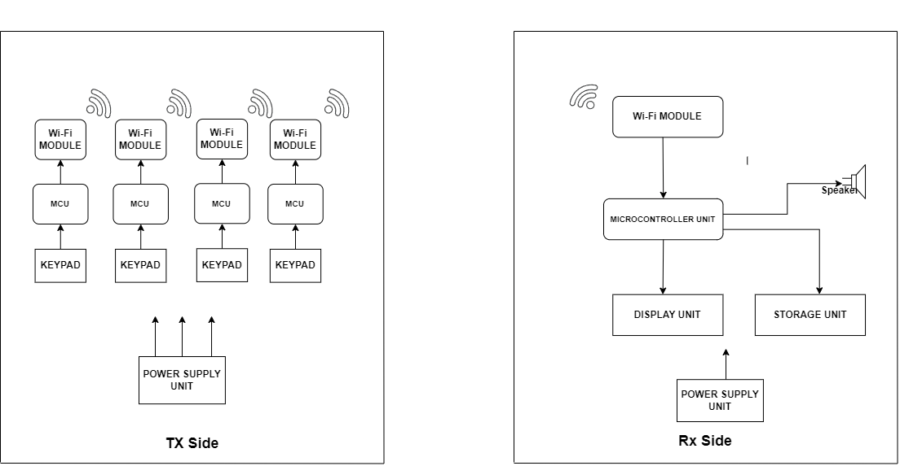



Figure 1: The block diagram of the system receiver and transmitter side

4

# **IMPLEMENTATION OF THE SYSTEM**

This is the step-by-step procedures in the development of the system

## **Developing a token printing machine**

This is the initiation part of the system, where it dispenses tokens which a programmed with a number on it for the customers to secure their spot in the que in a service provision center.

**Requirements**

**Software Requirements**

The software requirements were:

* Arduino IDE
* Printer libraries
* LCD displays Arduino libraries
* Power of 5V input to the printer

**Hardware Requirement**

The hardware requirements were:

* Arduino board
* Arda fruit token printer
* PCB board
* Jumper wires
* 5V power source
* LCD display

**Development**

Initially started by programming the printer to print out tokens by the Arduino board after setting connections in the transmitter and receiver nodes in the printer and Arduino by using the jumper wires

5

**Components used:**

**LCD display:** this is the component for displays the welcoming message to the customer and also displays the number of the token printed

**The button**: this is a component that the customer presses to receive successful his or her

token receipt

**A micro-controller:** this is the the microprocessor is also mounted on, the brain of the system, the part where all the programming and coding goes the Arduino complements these features

**The Arda fruit token printer**: this programmed to print a token right after the button is pressed

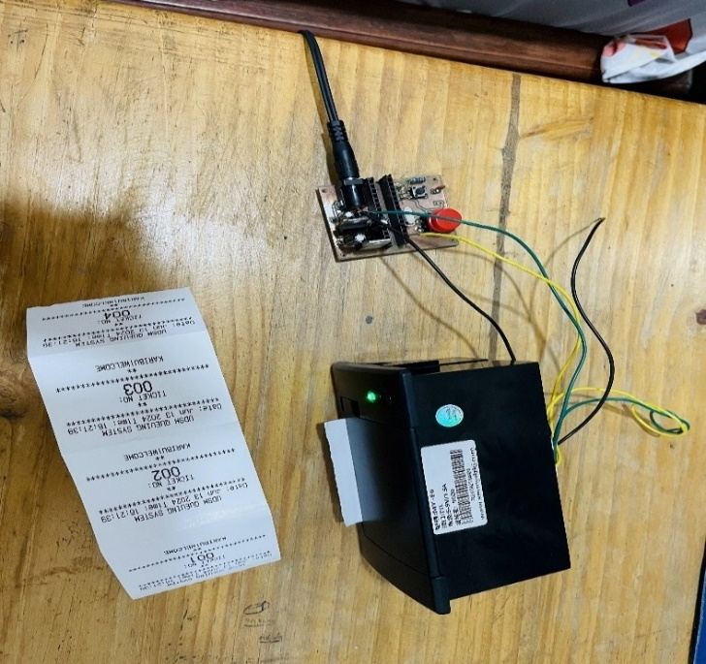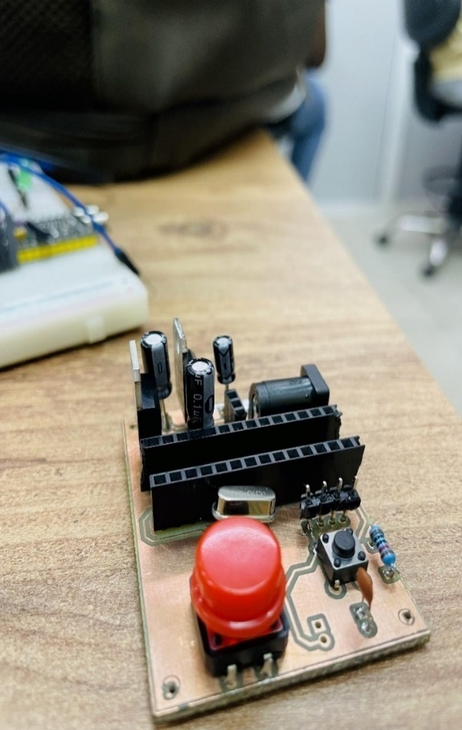

Figure 2: the Arda fruit printer Figure 3: board mounted with components

6

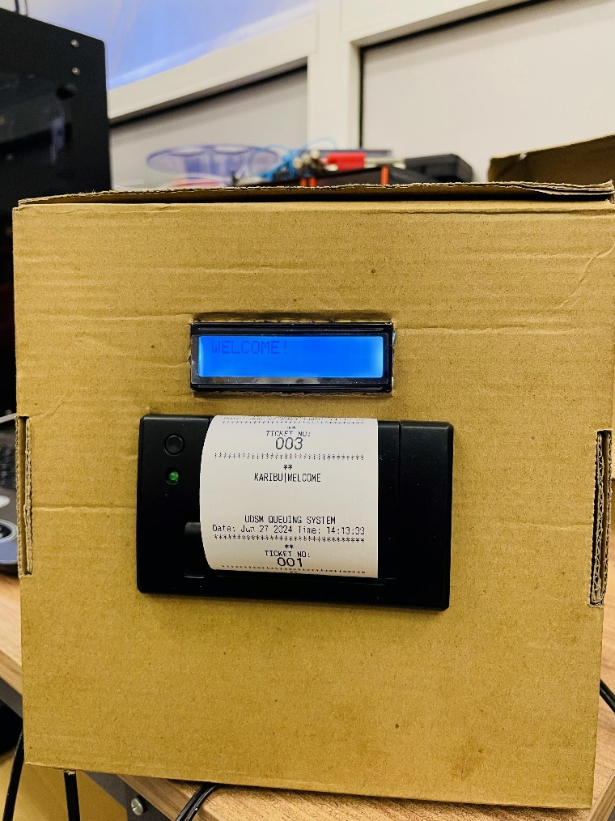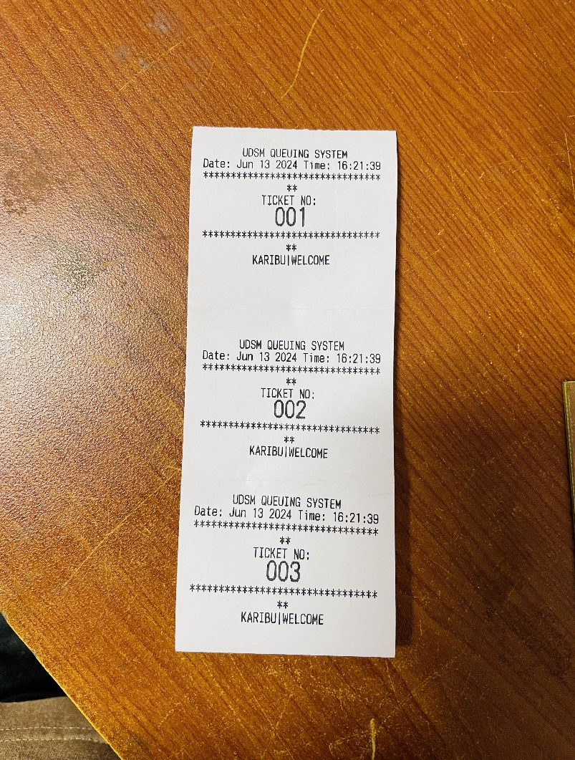

Figure 4 The token printer cased Figure 5: Sample of a token

**Functionality**: when the button is pressed the printer prints out the token with a token number and other necessary information like time and date and also the process is displayed on the LCD display.

**Testing and controlling of the printer part**

The process of programming the printer is a recurring process it can be re-programmed again when the system part showcased limitations, control throughout all the phases is necessary for better increment of efficiency and accuracy and error-free experience of the system part, figuring out problems like why the printer is printing tokens with fading words, why does the number of token not being printed on the token, improper display on the LCD display and thorough review of the code and testing whether all requirements of the power needs and circuitry of the part of the system

7

## **Development and implementing counter for calling tokens**

As observed on the system’s structure from the block diagram the core responsibility of the counter is to update on the next-served customer and show the now being-served customer, this in service provision centers will be located to the service providers side for instance the tellers at the banks

**Requirements**

**Software Requirements**

* Arduino IDE
* Transmitter’s library and extensions
* Keypad library and extensions

**Hardware Requirements**

* Transmitters
* Keypad
* Display
* Power source

**Components used**

The components used were:

ESP 32 transmitter:

4x4 Keypad

LCD display

8

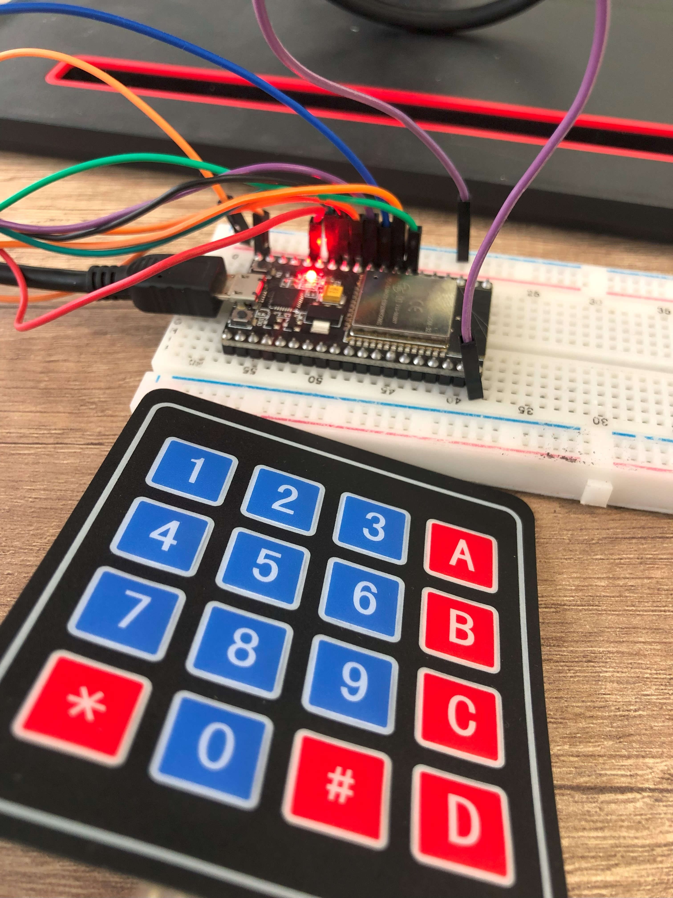

Figure 6: 4x4 Keypad

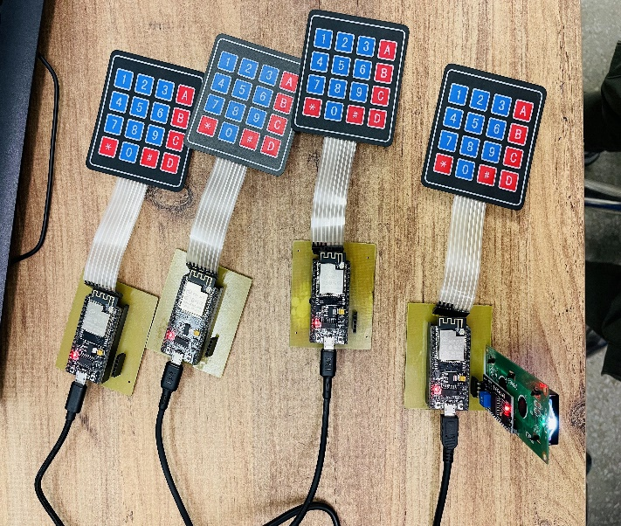 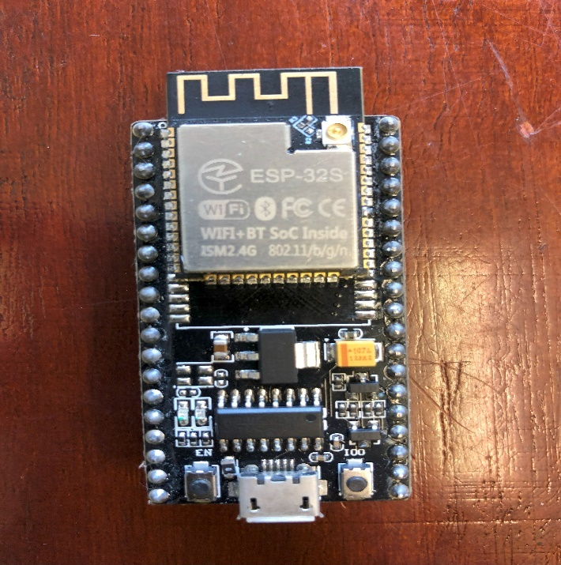  
Figure 7: ESP 32 Figure 8: ESP32 connected to keypad

9

**Implementation:** the ESP32 is programmed by the aid of Arduino IDE, and provided with the functionalities for when a key is pressed on the key pad and also to display the on-going actions on the display or the screen, the keypad is connected to the ESP32 via communication pins and same as the LCD display and all these components as a whole manifest the required functionality of the counter.

The counter as a whole when containing its well mounted and fixed components is contained in a 3D printed case which provides a eye-catching structure of the counters and the protection of the internal components

**Functionality:** what happens on the counter side is that the tellers or the service providers are provided with options to call the next customer, to called returned tokens or customers and also the ability to clear the token displayed

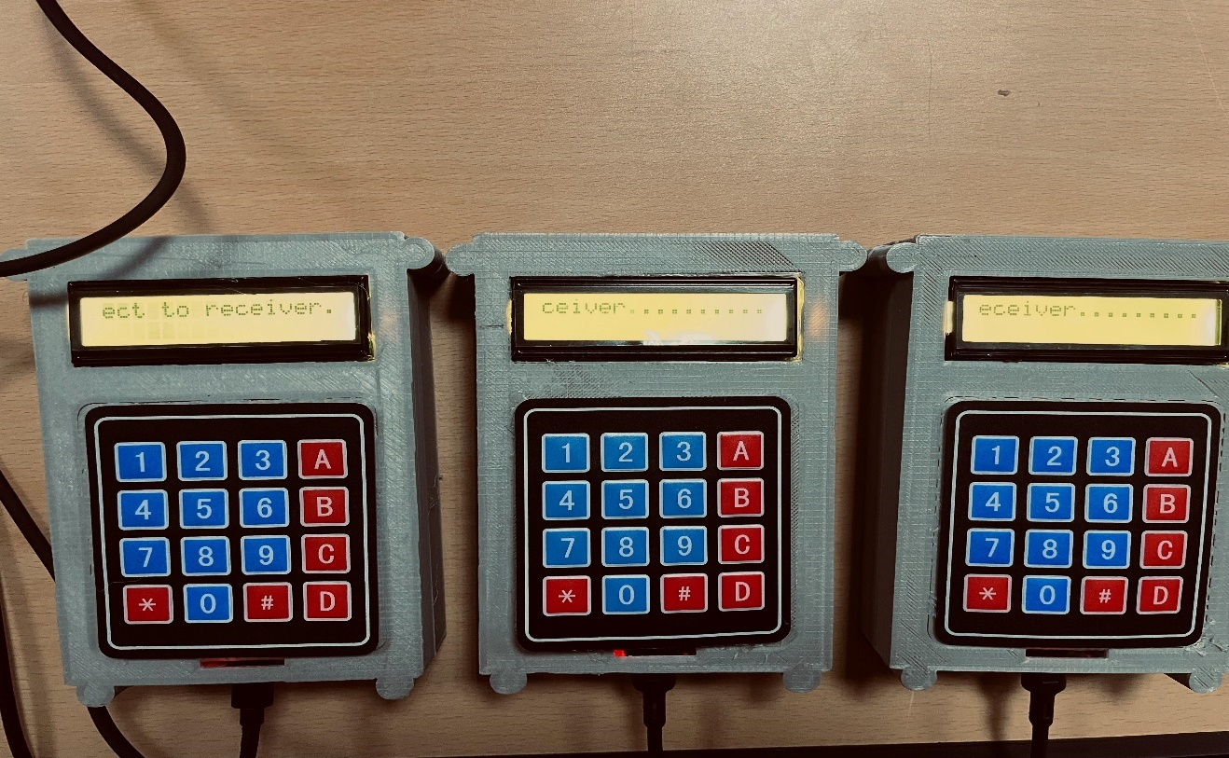

Figure 9: The counters programmed

**Testing and control**

Testing if the device performs the functionalities at the required standard and also monitoring and controlling whether there will be occurrence of errors and uncertainties in the device like improper response from keys on the keypad and improper display.

10

## **Establishing a centralized database to enable synchronization of token information across counters**

The system was viewed to potentially have a limitation on the communication between the counters thus leading to token change lack of synchronization. Thus, the prior method to tackle this is to involve a centralized pool or database that will facilitate all this.

A Database is an organized collection of data that allows for efficient storage, retrieval, and management, often facilitated by a database management system (DBMS) (Elmasri, 2016).

Also, one can refer it as a structured set of data held in a computer, especially one that is accessible in various ways to support various application and queries. (Silberschatz, 2011)

The effectiveness of the system relies on its strong ability to synchronize information across multiple service counter. A centralized database plays a role in ensuring that data is consistently updated and accessible allowing efficient management and improved customer experience

**Importance of a centralized database:**

* Data integrity and consistency, it ensures that all counters can operate from the same dataset reducing discrepancies in token management, ensuring that every counter can retrieve the latest information on token status either called, waiting, or expired, minimizing confusion for both staffs and customers.
* Scalability, as service demands increase, the system can be expanded by adding more counters without compromising data integrity and also supports future enhancements such as integration with additional services or features, like customer feedback systems.
* Real-time updates, changes in the token status at one counter are instantly reflected across all counters, facilitates immediate response to customer flow and reduces waiting times by dynamically managing resources based on current data.

11

**Data Synchronization Mechanisms:**

1. **APIs for data Communication**

* Development of application programming interfaces (APIs) that allow real-time data exchanges between the database and counters
* Ensures that when a token is called at one counter all other receive updates instantly

1. **Polling and web sockets**

* Implementation of polling mechanisms or web sockets connections for real-time data synchronization, allowing for immediate updates without constant refreshing
* Considerations for network reliability and latency to maintain a seamless user experience

**Security considerations:**

1. Data protection

* Implanting encryption for sensitive customer data to protect against unauthorized access
* Regular audits and compliance with data protection regulations such as GDPR, as applicable

1. User Authentication and authorization

* Establishing robust user authentication protocols to ensure that only authorized personnel can access or modify data
* Role-based access control (RBAC) to manage permissions based on user responsibilities.

12

**Challenges and solutions**

1. Data migration

* Addressing potential issues in migrating existing token data to the new centralized database
* Developing comprehensive strategies for data validation and verification post-migration.

1. System downtime

* Planning for minimal disruption during database updates or maintenance.
* Implementing failover strategies and backup systems to ensure continuous availability

Thus, the establishment of a centralized database is a cornerstone of an efficient electronic queuing system. By synchronization token information across counters, we can enhance the overall functionality and user experience, paving the way for the streamlined service process. Future work will focus on refining this system and integrating additional features to adapt to evolving user needs. thus, established and integrated to the system in order in increase awareness and efficiency of the system

## **To implement a display and a voice for token call up for better user experience**

In service centers with several counters, controlling client flow can frequently become difficult without workable methods that successfully interact with consumers. Customers become confused because visual and aural clues are either absent or inadequate in the majority of modern

13

queuing systems.

The lack of voice announcements and visual displays can reduce efficiency, create anxiety for customers, and hinder effective management. This objective aims to overcome these issues by implementing a display system along with a voice call feature to enhance customer experience and make queuing more intuitive.

**Need for Display and Voice in Queuing Systems**

To enhance customer experience, especially in environments where there are multiple service providers (counters, rooms, or offices), visual and auditory cues play a critical role. A visual display enables customers to see their token number and the corresponding counter they need to visit, ensuring a seamless transition from waiting to being served.

Simultaneously, integrating a voice announcement for token numbers offers an additional layer of communication, making the system accessible to customers who may not be closely monitoring the display. This is particularly useful in busy environments where customers may be distracted, or for those who are visually impaired, ensuring inclusivity in customer service. In addition to these core functions, the display can be used to provide other critical information, including ongoing promotions, instructions for customers, and general service announcements.

**Components of the Display and Voice Call System**

* **Display Technology**, Token numbers and the corresponding counter are shown on a digital screen as part of the display system. The screen should be big and prominently displayed so that all clients who are waiting may see it for best results. Depending on the particular needs of the service center, the suggested solution can make use of LCD or LED displays. LED screens are useful in practically every situation due to their extreme

brightness and visibility, even in highly illuminated or outdoor settings.  
As fresh tokens are called, the screen's content will update dynamically. When necessary, further information such as typical wait times, promotional materials, or safety instructions can be shown. A graphical user interface (GUI) can be used to design the display.

14

* **Voice Announcement System,**

The voice call feature complements the visual display by announcing the token number and the corresponding counter aloud. This reduces the risk of customers missing their turn, particularly if they are seated far from the display or engaged in other activities. The voice system can be designed with customizable settings, allowing the service provider to choose the language of announcements, volume control, and even the tone or type of voice (e.g., male/female, formal/informal).

Also, it is important that the volume levels are adjustable to suit different environments, such as a quiet office or a bustling service center. Moreover, multiple languages could be supported in areas where the customer base is diverse, ensuring the system is inclusive and accessible to non-native speakers.

**Advantages of a Display and Voice System**

* **Increased Customer Satisfaction**

A major benefit of this system is the improvement in customer satisfaction. When customers are able to easily track the progression of the queue, they are less likely to feel anxious about their wait time. This transparency helps in managing customer expectations, as they can visually and audibly confirm when their turn is approaching. The voice call-up system provides an added layer of assurance that no token will be missed due to distractions.

* **Enhanced Efficiency in Service Delivery**

Service providers can also benefit from the system's efficiency. With tokens being called up clearly and audibly, the workflow is streamlined, reducing confusion and delays. The display can show which counters are open or closed, giving customers a clear understanding of where to proceed.

* **Customization for Promotional Content** Another key advantage of the display is its ability to showcase content other than token information. During periods of low

**15**

activity, the service provider can use the screen to advertise services, promotions, or other relevant information. This not only increases the visibility of the service center’s offerings but also helps keep customers engaged while they wait.

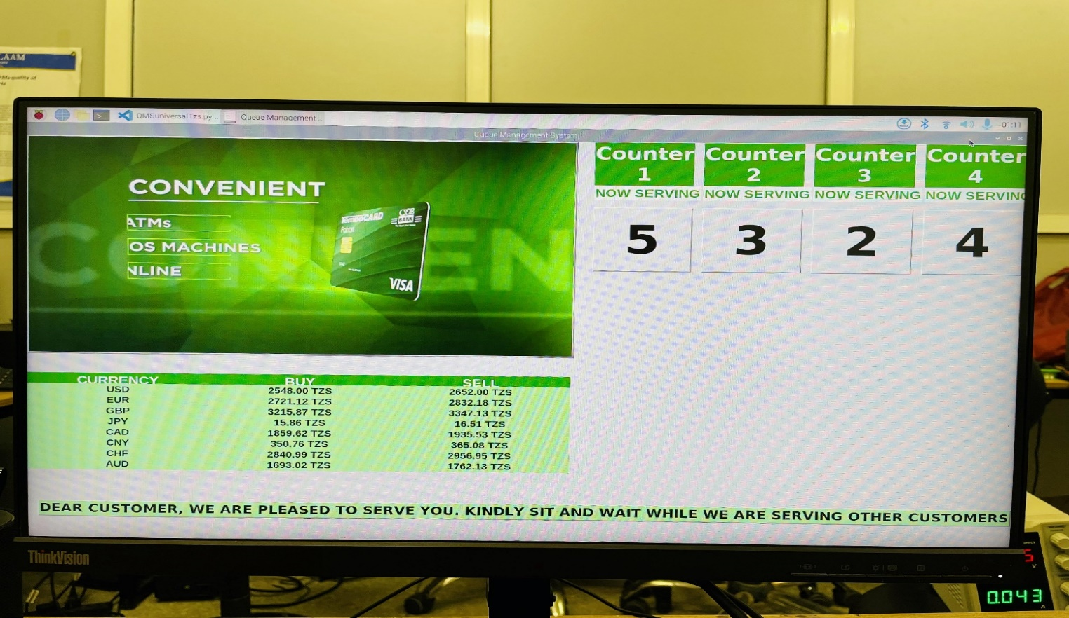

Figure 10: The customer visual interactive display

The display and voice system must be closely synchronized with the database. When a counter operator serves the next token, the system will instantly update the screen and initiate the voice announcement. This real-time updating is essential for the smooth operation of the system.

Also, the combination of visual and auditory elements ensures that the system is accessible to all, regardless of language or sensory impairments, making it an ideal solution for modern customer service centers.

## **To integrate token printing into the rest of the electronic queuing system**

In the modern service provision landscape, efficiency and customer satisfaction are paramount. One crucial component in enhancing these aspects is the integration of token printing into electronic queuing systems. This objective focuses on the seamless incorporation of token printing functionality within the existing framework of the electronic queuing system, utilizing a wireless communication network between the printer and a Raspberry Pi to facilitate real-time

16

data transfer and processing.

**1. Integration of Token Printing**

The token printer serves as a vital interface between the service provider and the customer, offering a tangible representation of the queue position. When customers arrive at the service point, they can request a token that indicates their order in the line. This token, printed on demand, provides not only a number but also important information such as service type and estimated wait time. The ability to print tokens quickly and accurately helps manage customer expectations and reduces perceived wait times.

The integration process involves programming an Arduino board to control a token printer, while a Raspberry Pi serves as the central controller, allowing flexibility in placement and adaptability to various service environments.

**2. Mode of Communication:** Wi-Fi Network

Utilizing a Wi-Fi network for communication between the printer and the Raspberry Pi offers several advantages:

* **Real-Time Data Transfer:** The Wi-Fi connection allows immediate transmission of data, ensuring that tokens are printed without delay, reflecting the current state of the queue.
* **Remote Management:** Service providers can monitor and manage the queuing system remotely, allowing for quick adjustments to the printing process or troubleshooting without needing to be physically present.
* **Scalability:** As the service grows, additional printers or Raspberry Pi units can be added to the network with minimal reconfiguration, enhancing the system's scalability.
* **Reduced Clutter:** Wireless communication minimizes the need for physical connections, reducing clutter and simplifying the overall setup.

**17**

# **ANALYSIS AND IMPORTANCE OF THE SYSTEM**

Integrating token printing into the electronic queuing system is not just about technology; it has profound implications for service provision. The importance of this system can be summarized in the following key areas:

* **Enhanced Customer Experience:** By providing printed tokens, customers receive immediate confirmation of their place in line. This transparency significantly reduces anxiety and improves satisfaction as they can manage their time better while waiting for service.
* **Efficient Queue Management:** The system allows for better organization of service delivery. Service providers can efficiently manage the flow of customers based on real-time data, reducing bottlenecks and ensuring that service resources are allocated appropriately.
* **Data Collection and Analysis:** The integration allows for the collection of valuable data regarding customer flow and service efficiency. Analyzing this data can lead to improvements in service delivery and operational efficiency, ultimately benefiting both the provider and the customer.
* **Impact on Service Provision Sector:** The implementation of an integrated electronic queuing system with token printing is transformative in the service provision sector. It enhances operational efficiency, fosters better customer relationships, and creates a more pleasant environment for both customers and service providers. The ability to provide timely, transparent service positions providers as customer-focused organizations, which is crucial in a competitive marketplace.

The integration of token printing into electronic queuing systems enhances customer flow and experience by utilizing a Wi-Fi network for communication between the printer and Raspberry Pi, thereby positioning organizations to meet customer needs.

.

18

**Economic and Developmental Impacts of the Queuing System**

Here are how the system might shake or impact the economy and the development part as a whole:

**1. Increased Efficiency and Reduced Costs**

Queuing systems automate queue management, eliminating manual procedures and personnel costs. This frees up resources for more important tasks, boosting revenue and reducing operating expenses. Quick customer turnover also benefits businesses.

**2**. **Enhanced Customer Satisfaction Leading to Higher Revenue**

The system enhances customer satisfaction through efficient queue management and token printing, reducing waiting times and promoting transparency, leading to increased customer loyalty, repeat business, and increased market share.

**3**. **Support for Business Growth and Scalability**

The queuing system, integrated with token printing and wireless communication, enables businesses to scale and expand without significant infrastructure changes, ensuring efficient service delivery and effective customer management in urban areas.

**4. Fostering Technological Advancement and Innovation**

Electronic queuing systems encourage technological innovation in businesses by improving data analytics, wireless communication, and customer service management tools. This results in sophisticated solutions for service delivery and operational effectiveness.

**5.** **Contribution to Sustainable Development Goals (SDGs)**

The queuing system also contributes to broader developmental objectives, including the Sustainable Development Goals (Nations, 2015). By optimizing resource use and minimizing wasted time for both customers and staff, the system aligns with goals related to economic growth, industry innovation, and responsible consumption. Moreover, its ability to function efficiently with minimal physical infrastructure supports sustainable practices by reducing the need for paper-based processes and excess staff energy usage.

19

# **CONCLUSION**

The electronic queuing system into service environments represents a significant step forward in modernizing customer service management. By streamlining queue handling and using wireless communication, the system enhances operational efficiency and customer satisfaction. It reduces waiting times, improves transparency, and allows businesses to serve more clients with fewer resources, directly impacting profitability.

Additionally, In the broader market, this system has the potential to revolutionize industries that rely on managing large volumes of customers, such as healthcare, banking, retail, and public services. Its ability to scale with business growth and its adaptability to various service environments make it a versatile solution for both small businesses and large enterprises. As more companies adopt such systems, they set a new standard for efficiency and customer-centric service, forcing competitors to follow suit.

# **RECOMMENDATION**

In the future when developers want to improve the system then, A number of technologies may be added to the project to increase its usefulness and scalability. Faster customer identification and automated token issuing would be made possible by integrating RFID cards, while remote queue management and customer alerts might be made possible by a mobile app. Integration with the cloud would improve the system's flexibility by enabling real-time monitoring and data processing. Additionally, by using predictive insights, integrating analytics driven by AI might enhance resource allocation and customer flow. Last but not least, including voice help would enhance interactivity and accessibility, making the system easier to use for a larger audience.

I would like to also recommend that, students from the University of Dar es Salaam should be highly referred to ETE department so as to highly increase their skills in the intellectual side as well as a person as a whole

20

# **References**

Elmasri, R. &. (2016). *Fundamentals of Database systems (7th edition).* pearson.

Nations, U. (2015). *Transforming our world: The 2030 Agenda for Sustainable Development.* New York, NY: United Nations.

Ngulube, P. (November, 2021). *Handbook of Research on Mixed Methods Research in Information Science.*

Royce, W. W. (1970). *Managing the development of large software systems.* Proceedings of IEEE WESCON.

Silberschatz, A. K. (2011). *Database system concept.* McGraw-Hill.

21